**SQL AdHoc Requests Project**

## Q1. Provide the list of markets in which customer "Atliq Exclusive" operates its business in the APAC region ?

Ans :-

SELECT DISTINCT

market

FROM dim_customer

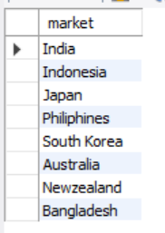WHERE customer = "Atliq Exclusive" AND region = "APAC";

## Q2. What is the percentage of unique product increase in 2021 vs. 2020?

Ans :-

WITH CTE_1 AS

(

SELECT COUNT( DISTINCT product_code) AS unique_products_2020 FROM fact_sales_monthly WHERE fiscal_year = 2020

),

CTE_2 AS

(

SELECT COUNT( DISTINCT product_code) AS unique_products_2021 FROM fact_sales_monthly WHERE fiscal_year = 2021

)

-- Main Query :-

SELECT

unique_products_2020,

unique_products_2021,

ROUND(((unique_products_2021 - unique_products_2020)*100.0)/unique_products_2020,2) AS Percentage_Change

FROM CTE_1

CROSS JOIN CTE_2;

## 

## Q3. Provide a report with all the unique product counts for each segment and sort them in descending order of product counts.

Ans :-

SELECT

segment,

COUNT( DISTINCT product_code ) AS products_count

FROM dim_product

GROUP BY segment

ORDER BY products_count DESC;

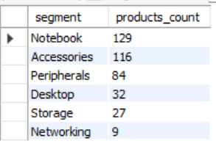

## Q4. Follow-up: Which segment had the most increase in unique products in 2021 vs 2020?

Ans :-

WITH PC_20 AS

(

SELECT

p.segment,

COUNT( DISTINCT p.product_code ) AS product_count_2020

FROM dim_product p

JOIN fact_sales_monthly s

ON p.product_code = s.product_code

WHERE s.fiscal_year = 2020

GROUP BY p.segment

),

PC_21 AS

(

SELECT

p.segment,

COUNT( DISTINCT p.product_code ) AS product_count_2021

FROM dim_product p

JOIN fact_sales_monthly s

ON p.product_code = s.product_code

WHERE s.fiscal_year = 2021

GROUP BY p.segment

)

-- Main Query :-

SELECT

PC_20.segment,

PC_20.product_count_2020,

PC_21.product_count_2021,

(PC_21.product_count_2021 - PC_20.product_count_2020) AS difference

FROM PC_20

JOIN PC_21

ON PC_20.segment = PC_21.segment

ORDER BY difference DESC;

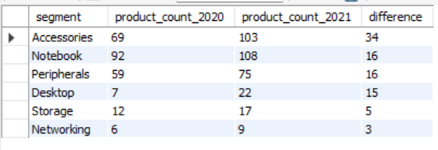

## Q5. Get the products that have the highest and lowest manufacturing costs.

Ans :-

WITH Max_Min_Cost AS (

SELECT

product_code,

manufacturing_cost

FROM fact_manufacturing_cost

WHERE manufacturing_cost = (SELECT MAX(manufacturing_cost) FROM fact_manufacturing_cost)

OR manufacturing_cost = (SELECT MIN(manufacturing_cost) FROM fact_manufacturing_cost)

)

SELECT

p.product_code,

p.product,

mc.manufacturing_cost

FROM Max_Min_Cost mc

JOIN dim_product p

ON mc.product_code = p.product_code

ORDER BY mc.manufacturing_cost DESC;

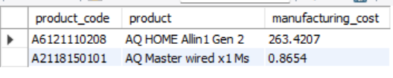

## Q6. Generate a report which contains the top 5 customers who received an average high pre_invoice_discount_pct for the fiscal year 2021 and in the Indian market.

Ans :-

SELECT

c.customer_code,

c.customer,

ROUND(AVG(pd.pre_invoice_discount_pct),2) AS Avg_pre_invoice_discount_pct

FROM fact_pre_invoice_deductions pd

JOIN dim_customer c

ON pd.customer_code = c.customer_code

WHERE pd.fiscal_year = 2021 AND c.market = 'India'

GROUP BY c.customer_code,c.customer

ORDER BY Avg_pre_invoice_discount_pct DESC

LIMIT 5;

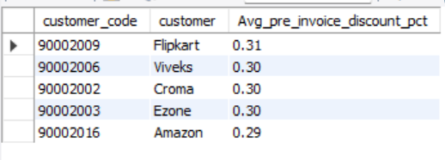

## Q7. Get the complete report of the Gross sales amount for the customer “Atliq Exclusive” for each month. This analysis helps to get an idea of low and high-performing months and take strategic decisions.

Ans :-

SELECT

MONTH(s.date) AS Month,

s.fiscal_year AS Year,

ROUND(SUM(g.gross_price * s.sold_quantity),2) AS Gross_Sales_Amount

FROM fact_gross_price g

JOIN fact_sales_monthly s

ON g.product_code = s.product_code AND g.fiscal_year = s.fiscal_year

JOIN dim_customer c

ON s.customer_code = c.customer_code

WHERE c.customer = "Atliq Exclusive"

GROUP BY MONTH(s.date),s.fiscal_year

ORDER BY s.fiscal_year, MONTH(s.date);

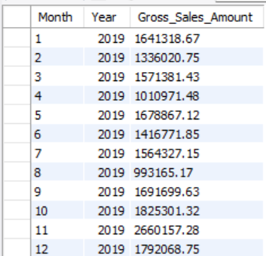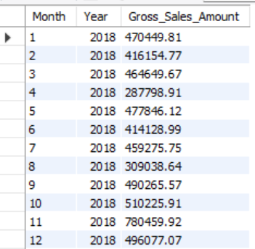

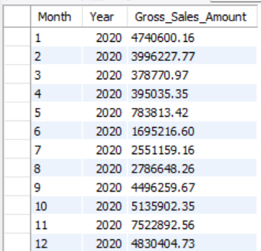

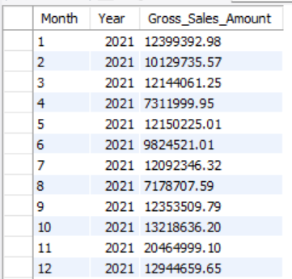

## Q8. In which quarter of 2020, got the maximum total_sold_quantity?

Ans :-

SELECT

CASE WHEN MONTHNAME(date) IN ('September','October','November') THEN 'Quarter 1'

WHEN MONTHNAME(date) IN ('December','January','February') THEN 'Quarter 2'

WHEN MONTHNAME(date) IN ('March','April','May') THEN 'Quarter 3'

ELSE 'Quarter 4' END AS Quarter,

ROUND(SUM(sold_quantity)/1000000,2) AS Total_Sold_Quantity_Mlns

FROM fact_sales_monthly

WHERE fiscal_year = 2020

GROUP BY Quarter

ORDER BY Total_Sold_Quantity_Mlns DESC;

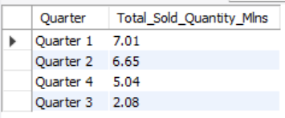

## Q9. Which channel helped to bring more gross sales in the fiscal year 2021 and the percentage of contribution?

Ans :-

WITH CTE_1 AS

(

SELECT

c.channel,

ROUND(SUM(s.sold_quantity * g.gross_price )/1000000,2) AS gross_price_mlns

FROM dim_customer c

JOIN fact_sales_monthly s

ON c.customer_code = s.customer_code

JOIN fact_gross_price g

ON s.product_code = g.product_code AND s.fiscal_year = g.fiscal_year

WHERE s.fiscal_year = 2021

GROUP BY c.channel

)

-- Main Query :-

SELECT

channel,

gross_price_mlns,

ROUND(gross_price_mlns * 100 / (SELECT SUM(gross_price_mlns) FROM CTE_1),2) AS percentage

FROM CTE_1

GROUP BY channel

ORDER BY gross_price_mlns DESC;

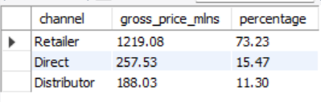

## Q10. Get the Top 3 products in each division that have a high total_sold_quantity in the fiscal_year 2021?

Ans :-

WITH CTE_1 AS

(

SELECT

p.division,

p.product_code,

p.product,

SUM(s.sold_quantity) AS total_sold_qty,

DENSE_RANK() OVER(PARTITION BY p.division ORDER BY SUM(s.sold_quantity) DESC) AS ranking

FROM dim_product p

JOIN fact_sales_monthly s

ON p.product_code = s.product_code

WHERE s.fiscal_year = 2021

GROUP BY p.division,p.product_code,p.product

)

-- Main Query :-

SELECT * FROM CTE_1 WHERE ranking <= 3;

